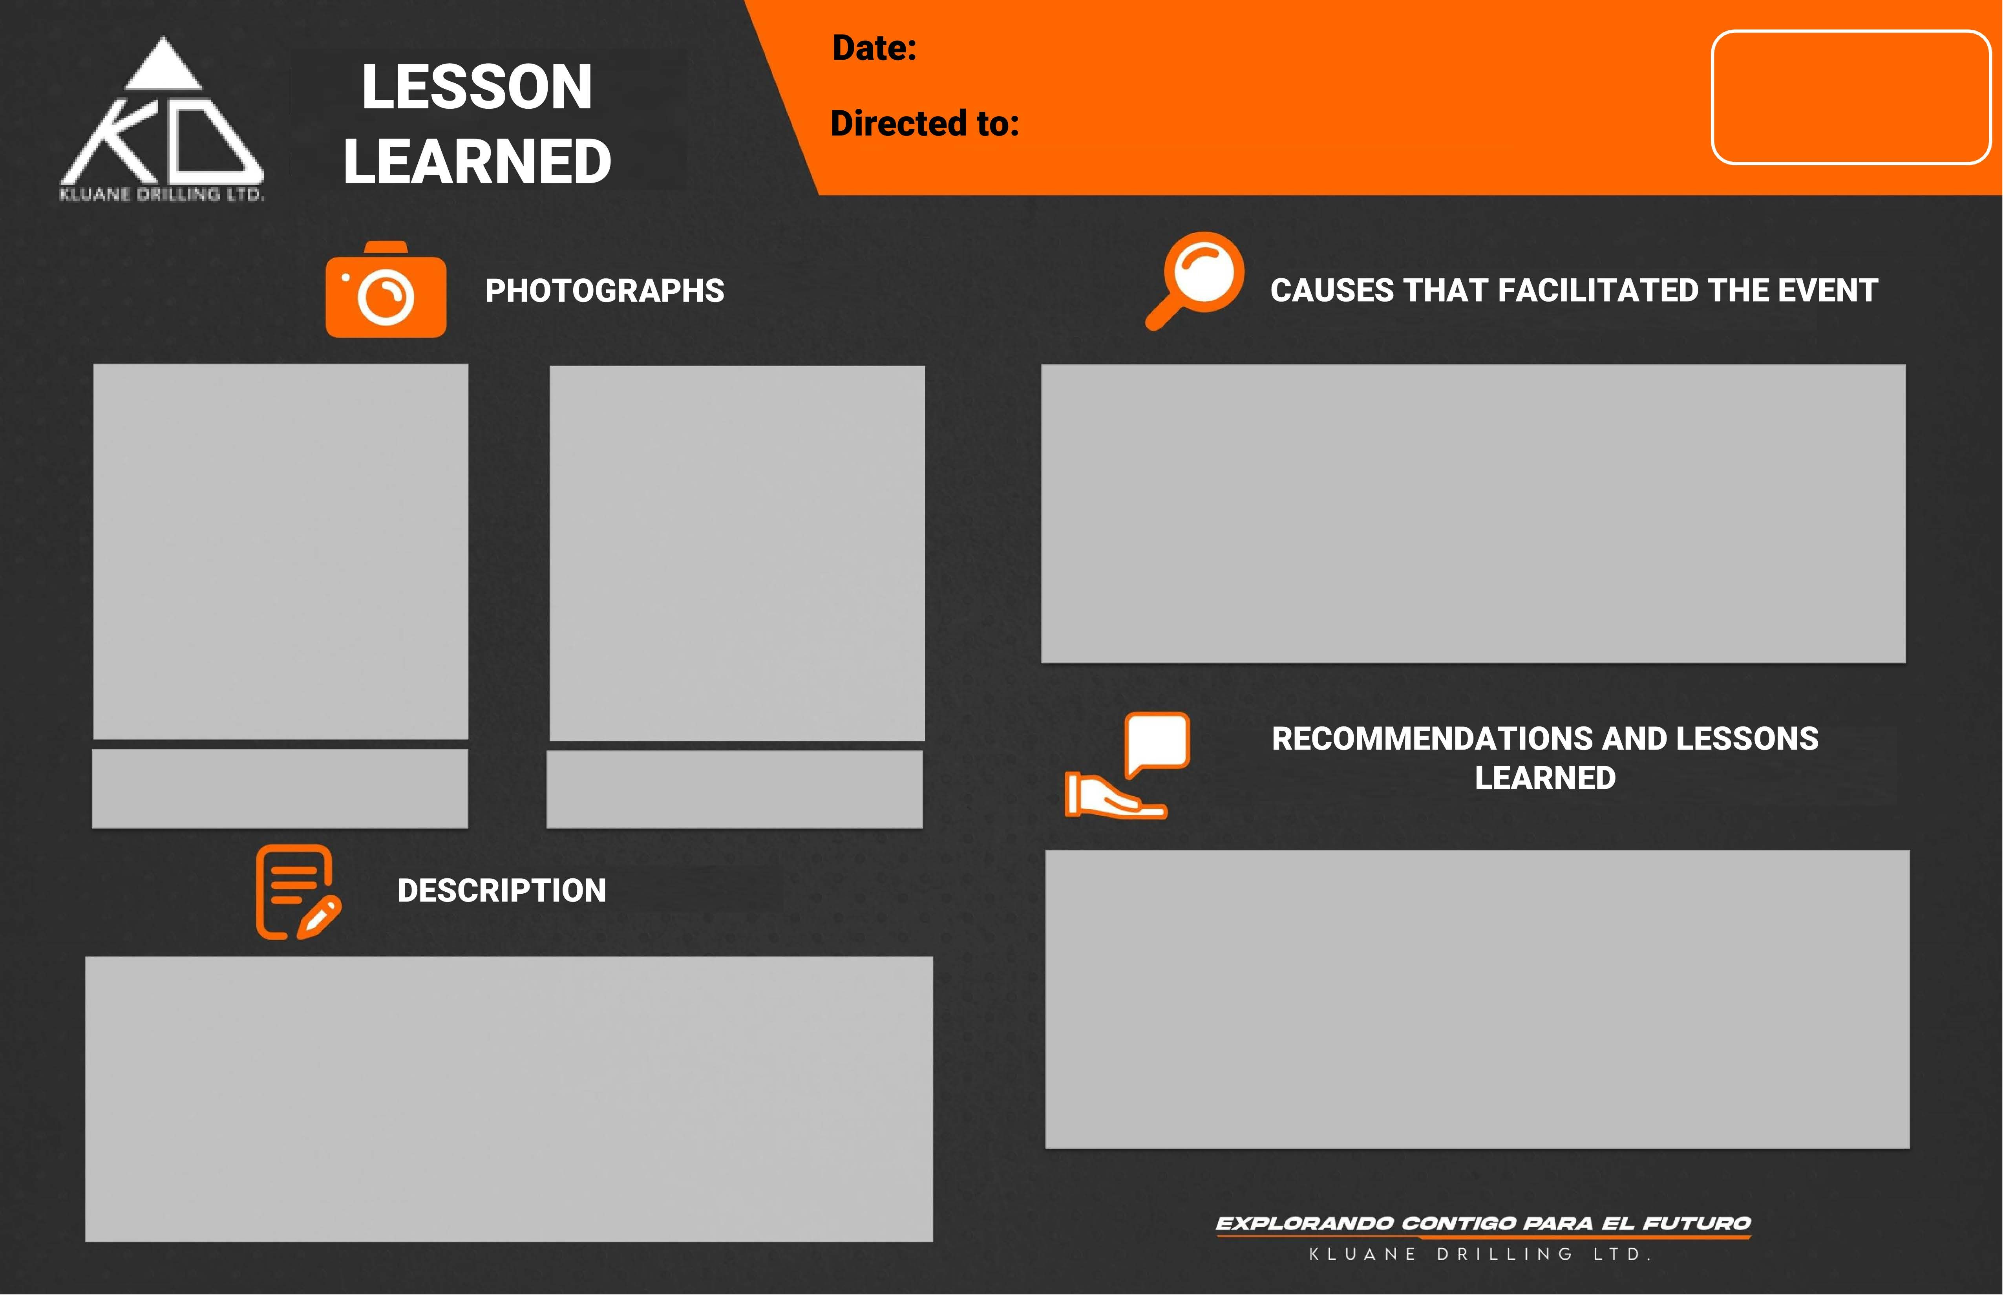

To all Kluane Drilling workers and active projects

CA-HSE-F-10.E
REV 2
MAY-2023

