
DRIVER APPROVAL INSTRUCTION
KLUANE DRILLING LTD.
HR COORDINATOR Last updated: 07/November/2024
- RESPONSIBILITIES:
JOB POSITION | RESPONSIBILITIES IN THIS PROCEDURE
HR Coordinator | Obtain, file, update and submit documentation to insurance company, disciplinary process as required
Operations Manager | Ensure compliance with set procedures
Fleet & Maintenance Manager | Support Operations Manager with ensuring compliance
Drilling Supervisor / Site foreman | Ensure compliance with set procedures on site

- INSTRUCTIONS (DO - CHECK):

Everyone who is going to drive a company’s vehicle must added to the driver’s list of insurance, as long as they meet the following requirements.

ONLY approved drivers are permitted to operate a company vehicle they are licensed to operate.

HR Coordinator to obtain relevant information from Employees at the time of hiring and annually for existing employees and when there have been any changes.

To ensure that you are reviewing the documents correctly, check the following:

  - Driver’s License for the class of vehicle to be driven.

    - Class 5 for cars and pickup trucks
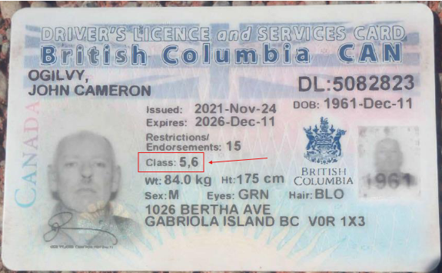
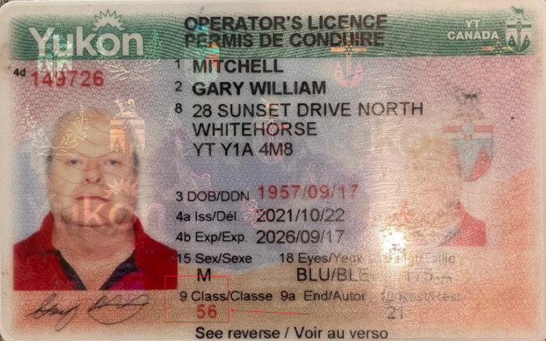

TFW (Other Country) It will depend on the country you come from

Mexico Ecuador
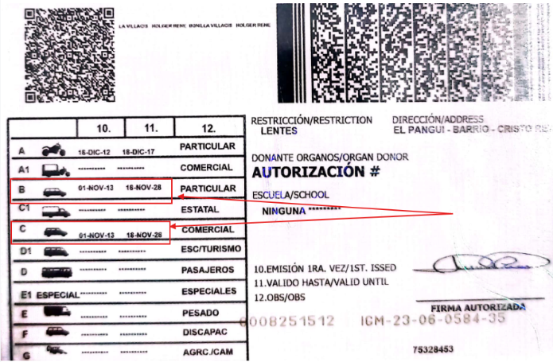
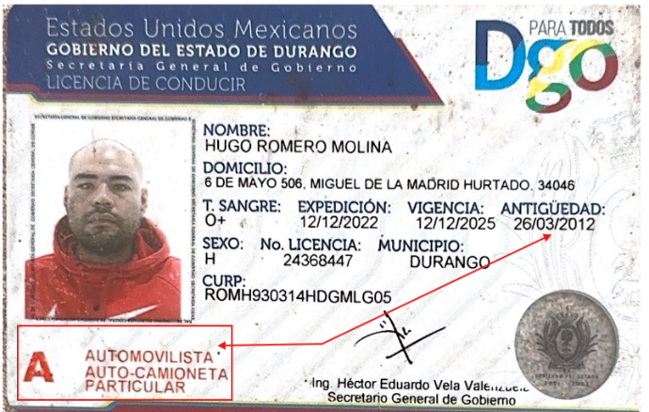

    - Class 3 for Water Trucks and dump trucks

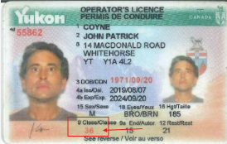

    - Class 1 for Highway Tractor Trailers trucks
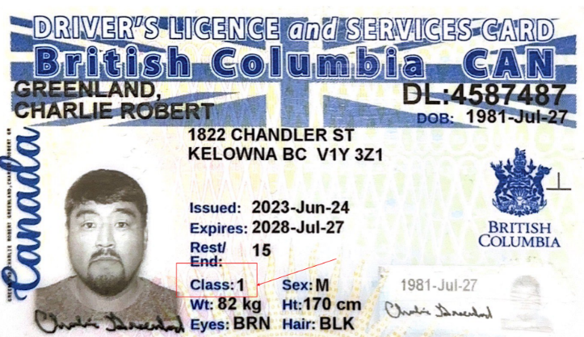
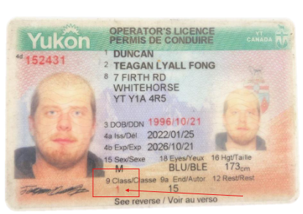

    - Employee with Class 7 license (learners) will not be added to driver list.

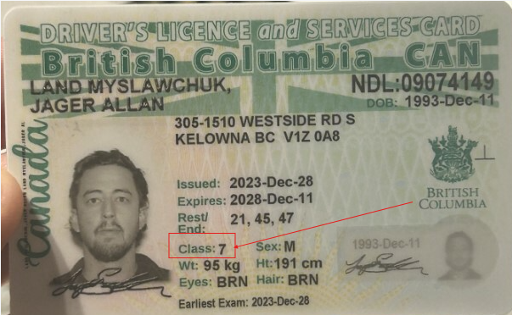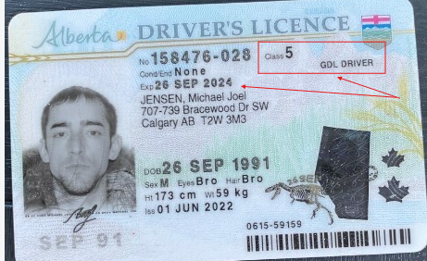

Probationary Class 5-Graduated Driver's Licence (GDL)

  - For an Employee of Kluane or third parties added with a Class 3 or Class 1 license that you want to have approved for larger vehicles email the appropriate driver abstract consent form as in (1) above AND have the employee complete the form Intact Driver Profile Survey. For instructions to complete the form see Driver Profile Survey Instructions. You will then email the appropriate driver abstract consent form from (1) above AND the complete Driver Profile Survey to the insurance company.
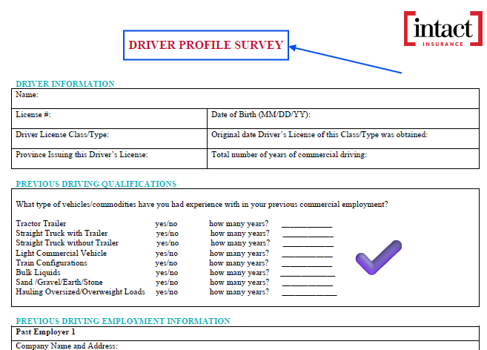

  - A minimum of 3 years of driving experience.

All drivers must have at least 3 years of driving under the class of license to which they will be added.

You have 2 ways to verify the years of driving experience, the first with the date of issuance of the license you are checking, and the second by checking the driver's record for the date of the first issuance of the driver's license.
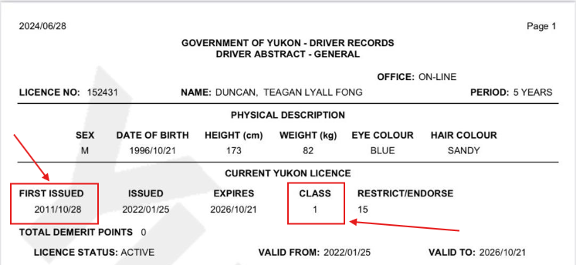
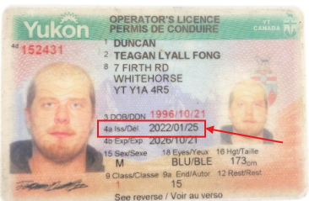
In case the license within the province of Yukon was recently issued, but the driver had a previous driver’s license, check the driver's years of driving through the driver's record of the province where he/she had his/her previous driver's license.
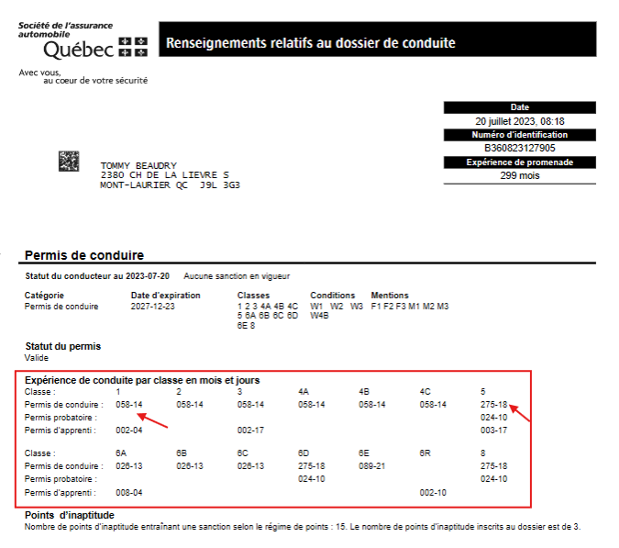

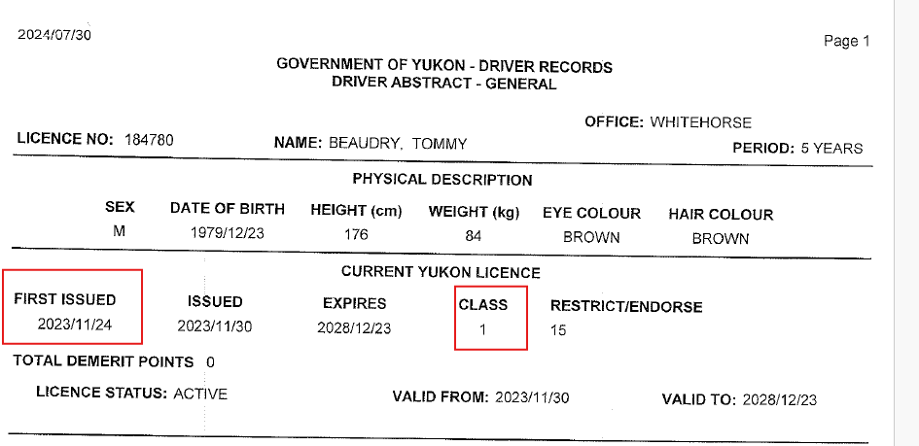

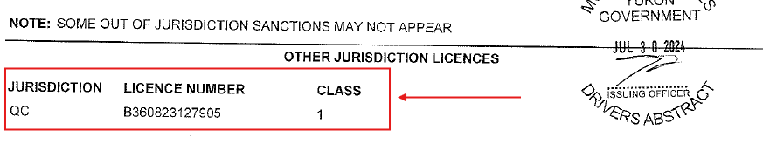

  - Must have a satisfactory driving record based on drivers abstract(s). Look at the driver’s and if any of the following are found DO NOT submit to the insurance company. This employee does NOT qualify to be on the insured driver’s list. On Monday.com put NO beside their name to indicate they CANNOT drive ANY Kluane fleet vehicles

For NON-permanent employees, a new driver abstract must be submitted annually to HR.

    - One or more at fault claims in last 3 years means can’t be authorized to drive without a special review process and requesting authorization from insurance company if there are special circumstances.

    - 3 or more minor convictions in last 3 years means can’t be authorized to drive without a special review process and requesting authorization from insurance company if there are special circumstances.

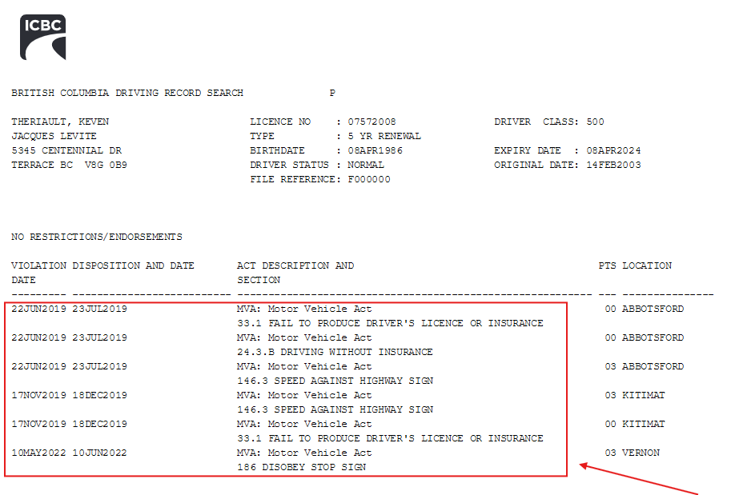

    - 1 or more major convictions in last 3 years means can’t be authorized to drive without a special review process and requesting authorization from insurance company if there are special circumstances.

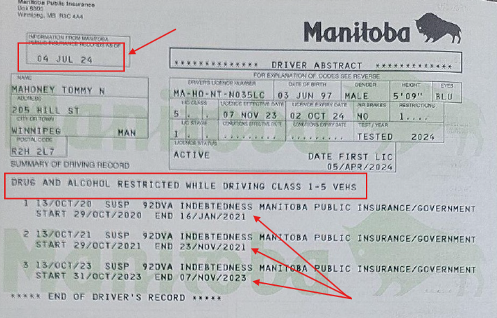

  - If the driver abstract is clear or meets the requirements above submit the following to the insurance company.

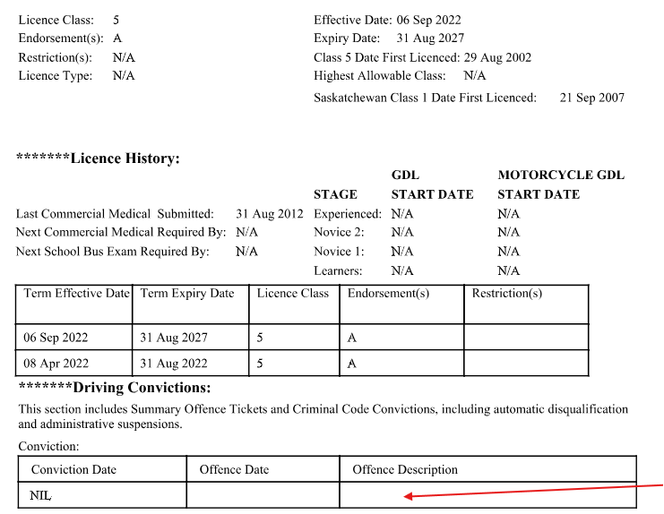

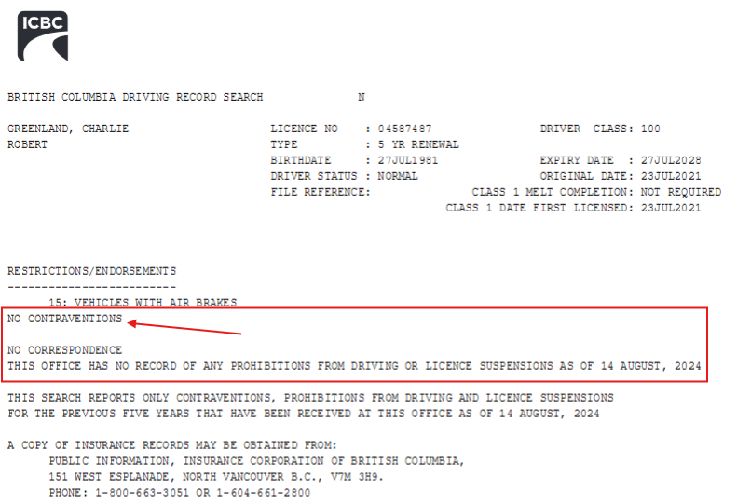

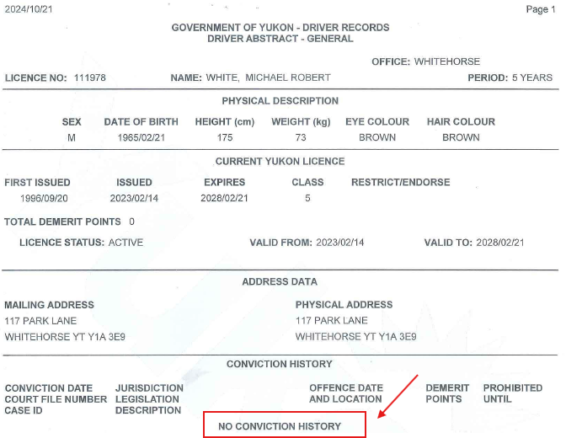

- DOCUMENTATION REQUIRED

Requirements for CANADIAN Employees to be on the Approved Driver List

- Employee to provide his valid Driver’s License for the class of vehicle to be driven.
- Employee to provide his driver's abstract for anywhere they have had a license in the past 3 years.
- If the driver's abstract is clear for at least the last 3 years, the driver must sign the consent/authorization.
C:\Users\DELL\Kluane Drilling\KluaneDrillingCanada - Shared\HR\ISO\7.2 Competence\Insured Driver List\Documents to complete and submit for approval
- For employees with a Yukon driver’s license the employee will need to complete and sign the form called Kluane Drilling Ltd – Driver Abstract Consent Form Yukon
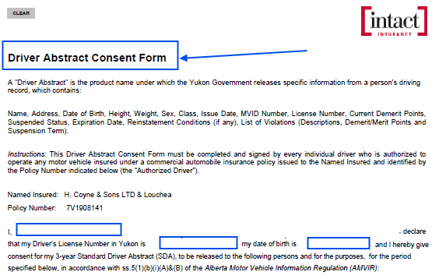

- For an employee with a Canadian license from any other province or territory except the Yukon the employee will need to complete and sign the form called MVR Form for Kluane Drilling Auth for Abstract
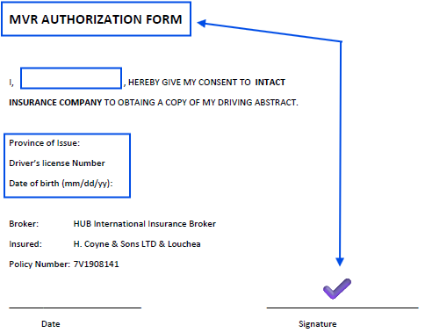

- Must complete a DRIVER PROFILE FORM if driving a vehicle larger than a pickup truck (if a class 3 or class 1 license is required for the vehicle they will be driving).
- If you want to change the status of a previously approved driver from class 5 to class 3 or 1, he must comply with all the above mentioned.

Requirements for TEMPORARY FOREIGN WORKERS to be on the Approved Driver List

- Employee to provide his valid driver's license.
- Employee to provide his driver's abstract from home country if available.
- If the drivers abstract is available, to translate the abstract (it doesn’t have to be a certified translation; you can do the translation yourself).
- Employment reference letter to verify their driving experience for at least 3 years. (KD Driver Reference Letter by Subsidiary)
C:\Users\DELL\Kluane Drilling\KluaneDrillingCanada - Shared\HR\ISO\7.2 Competence\Insured Driver List\Documents to complete and submit for approval
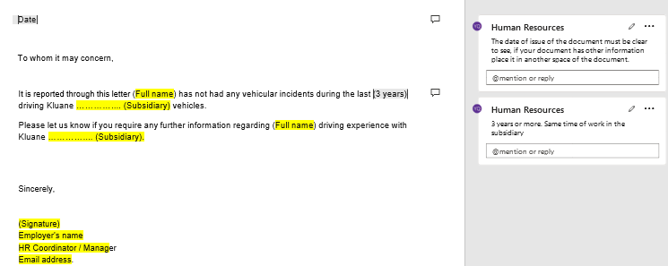
- To complete the Drive Profile survey only if the abstract is not available.

Requirements for VISITORS / SHORT Term Insured Driver List to be on the Approved Driver List

- Visitor/Short term driver to provide his valid Driver’s License for the class of vehicle to be driven.
- Visitor/Short term driver to provide his driver's abstract for anywhere they have had a license in the past 3 years (Mandatory for Canadians drivers) / (Only if available to foreign visitors).
- Reference letter to verify their driving experience for at least 3 years (KD Driver Reference Letter by Subsidiary- Only to foreign visitors).

- APPROVAL AND REGISTRATION

Once you have verified that the driver meets the requirements and has filled out the necessary forms, add him/her to the list of insured drivers.

- Excel sheet, be sure to include all the requested information such as date of inclusion, driver's name, date of birth, license number, and province.
(Be sure to add the new driver in the new additions Excel sheet, as well as in the current driver's list Excel sheet)

C:\Users\DELL\Kluane Drilling\KluaneDrillingCanada - Shared\HR\ISO\7.2 Competence\Insured Driver List
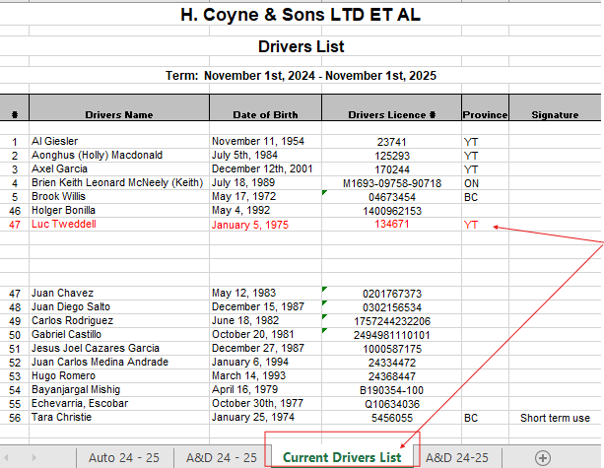

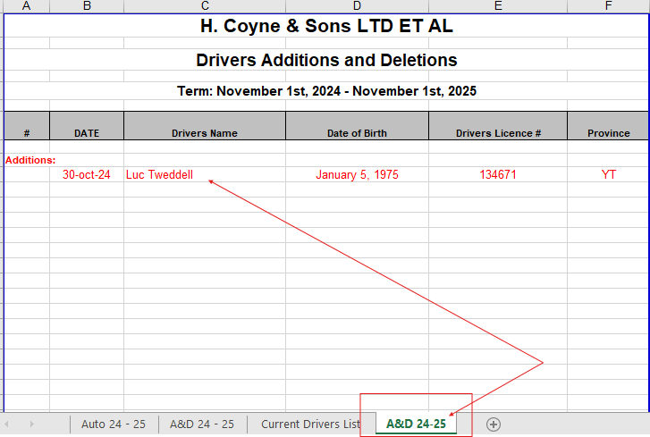

- If you want to exclude a previously approved driver, you must move the drivers from current drivers list to data A&D sheet – deletions.

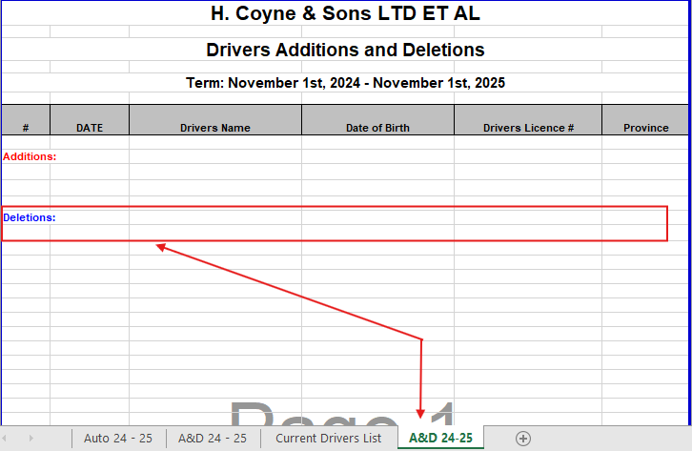

- Monday.com: date of inclusion, driver's name, date of birth, DL number, DL class, DL province, DL Country, Company, Role.
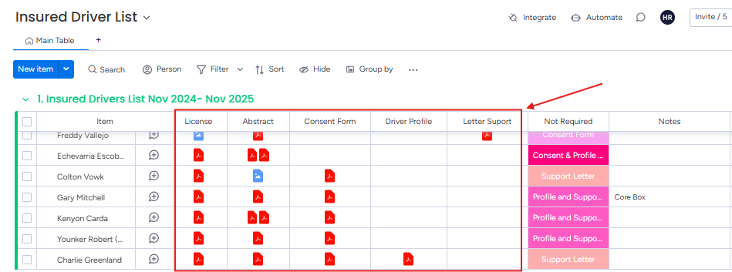
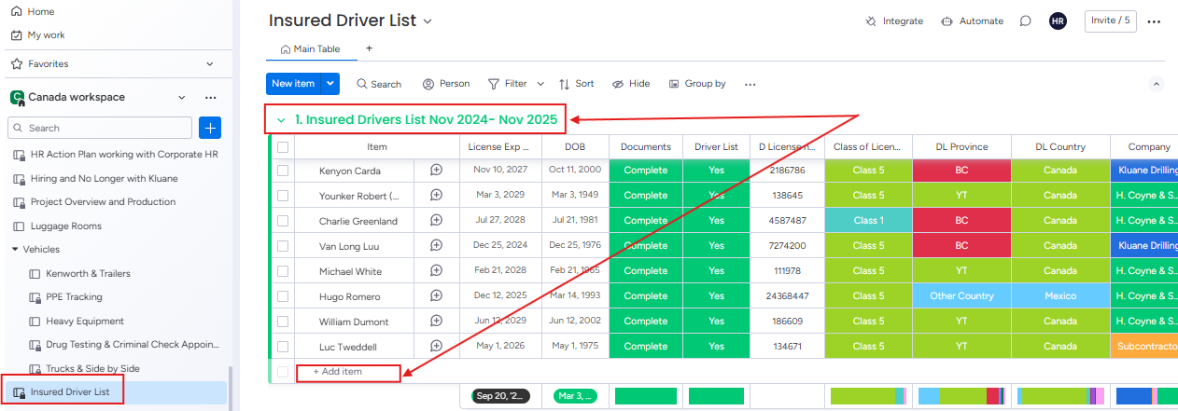
Be sure to upload all supporting documents.

- SEND A CONFIRMATION EMAIL TO OUR INSURANCE BROKER WITH THE UPDATED LIST OF INSURED DRIVERS.

CANADIAN Employees to be on the Approved Driver List

- Attach the Excel sheet with the updated list of insured drivers.
- Attach the Driver Abstract Consent Form Yukon or MVR Form signed as appropriate.
- In the email state that the employee has class 5, and if has a class 3 or a class 1 license state the type of vehicle the employee will be driving (eg. Dump truck, Water Truck, Highway tractor, and trailer).

TEMPORARY FOREIGN WORKERS to be on the Approved Driver List

- Attach the Excel sheet with the updated list of insured drivers.
- KD Driver Reference Letter by Subsidiary.
- Translated copy of the drivers abstract from country.
- In the email explain which country they are from and that their class of license is equal to the Class 5 license in Canada. Also say that the international employee will be driving pickup trucks only.

VISITORS / SHORT Term Insured Driver List to be on the Approved Driver List

- If you are adding a short-term driver or visitor, please explain how long he will drive in the body of the email that you are sending.
- Attach the Excel sheet with the updated list of insured drivers.
- A copy of the driver’s abstract is clear.

- CLOSING AND RENEWAL

If an employee does not meet the requirements to be on the Approved Driver List, but nonetheless is required to drive company vehicles due to the duties of their job position, a manual approval will be requested from the insurance company and additional information may be required such as employment reference letters.

HR Coordinator to update and file the information appropriately: Save the updated copy of the Vehicle Driver Schedule to HR>ISO>7.2 Competence>Insured Driver List and rename it with the date the updated.

HR Coordinator to get driver abstracts annually and submit them to the insurance company as needed.

- REFERENCE DOCUMENTS:
  - Driver License
  - Driver Abstract
  - Driver Profile Form
  - Employment Reference Letter
  - KD Driver Reference Letter Template Subsidiaries
  - Disciplinary Process
  - Approved Driver List board on Monday.com
  - Approved Driver List Excel sheet

